How do you perform a root cause analysis using JIRA data?
Performing Root Cause Analysis (RCA) Using JIRA Data
Root Cause Analysis (RCA) in JIRA involves tracking and analyzing issues, incidents, or defects to determine the underlying cause of a problem. Here’s a step-by-step approach to performing RCA using JIRA:

1. Identify the Problem
- Look at recent incidents, bugs, or failed deployments in JIRA.
- Check issue types like Bugs, Incidents, or Problem Reports.
- Review related JIRA tickets and error logs from integrations (e.g., Splunk, Datadog).

2. Gather Data Using JIRA Filters & JQL (JIRA Query Language)
- Use JIRA filters to find related issues:
  - Example JQL:
project = "Banking App" AND issuetype = Bug AND status = Closed AND resolution = Fixed AND created >= -7d
  - This query finds all closed bugs in the last 7 days that were fixed.
- Identify trends using custom fields like Priority, Root Cause, and Components.

3. Categorize the Issues
- Group issues based on symptoms, affected modules, or teams.
- Use JIRA labels or components to categorize defects (e.g., "Database Issue," "UI Bug," "Integration Error").
- Check linked issues (e.g., is this a recurring issue related to another ticket?).

4. Perform RCA Using the "5 Whys" Technique
For each critical issue, ask "Why?" five times until you find the root cause. Example:
- Why did the payment transaction fail? → API response timeout.
- Why did the API timeout? → The database query took too long.
- Why was the query slow? → Indexing issue in the transaction table.
- Why was indexing missing? → It was removed in the last database update.
- Why was it removed? → Lack of validation in the change management process.

5. Use JIRA Reports for Analysis
- Issue Statistics Report – Helps identify patterns (e.g., most common issue types).
- Created vs. Resolved Report – Compares issue inflow vs. resolution rate.
- Time Tracking Report – Identifies delays in bug fixes.
- Control Chart – Helps measure cycle time for defect resolution.

6. Implement Fixes & Prevent Future Recurrence
- Create a Problem Request to track the root cause resolution.
- Link all related tickets to the problem request.
- Update JIRA workflows to enforce preventive measures (e.g., add a review step for critical deployments).
- Schedule RCA review meetings with Engineering & QA teams.

7. Document RCA in JIRA & Confluence
- Add root cause findings to the JIRA ticket description.
- Update Confluence with an RCA report (linked to JIRA).
- Set up automated alerts for similar issues in the future.

Example RCA in JIRA
- Incident Ticket: Payment Gateway Failure
- Root Cause: API request timeout due to database latency.
- Resolution: Improved query indexing & optimized API retries.
- Preventive Action: Added performance tests before production deployment.
Day-to-Day Activities of a Scrum Master
A Scrum Master plays a crucial role in facilitating Agile processes, ensuring the team follows Scrum principles, and removing impediments to productivity. Below is a breakdown of a typical day in the life of a Scrum Master:

1. Daily Scrum (Stand-up Meeting)
- Facilitate the Daily Stand-up to ensure team members discuss:
  - What they worked on yesterday.
  - What they plan to do today.
  - Any blockers or challenges.
- Timebox the meeting to 15 minutes to keep it efficient.
- Identify and note any issues that need resolution.

2. Addressing Impediments & Blockers
- Actively resolve blockers faced by the team.
- Escalate dependencies or conflicts to the Product Owner or management if necessary.
- Work with other teams if there are cross-team dependencies.

3. Sprint Planning
- Ensure the Sprint Planning session is well-prepared.
- Assist the Product Owner in prioritizing backlog items.
- Help the development team understand story points and acceptance criteria.
- Guide the team in breaking down user stories into smaller tasks.

4. Sprint Execution & Monitoring
- Track team progress using JIRA dashboards or Kanban boards.
- Monitor burndown charts to ensure the team is on track.
- Encourage collaboration and knowledge sharing among team members.

5. Facilitate Meetings (Ceremonies)
- Daily Stand-up (Scrum Meeting) – Quick status check.
- Sprint Planning – Define the work for the next sprint.
- Backlog Refinement – Ensure the backlog is groomed and prioritized.
- Sprint Review – Showcase completed work to stakeholders.
- Sprint Retrospective – Discuss what went well and areas of improvement.

6. Collaboration with Stakeholders
- Work closely with:
  - Product Owner – Ensure backlog is well-defined and prioritized.
  - Developers & Testers – Help them remove any obstacles.
  - Business & Management – Provide updates on sprint progress.

7. Coaching & Agile Best Practices
- Mentor and coach the team on Agile principles.
- Conduct Scrum training for new team members.
- Encourage self-organizing teams and foster collaboration.

8. Jira & Reporting
- Update JIRA tasks, stories, and sprint boards.
- Generate velocity reports, burndown charts, and sprint progress dashboards.
- Track the team’s Sprint Goal completion.

9. Sprint Retrospective & Continuous Improvement
- Conduct Sprint Retrospective to identify improvements.
- Implement action items for process enhancements.
- Foster a culture of continuous improvement.

10. Supporting Engineering & Quality
- Ensure Definition of Done (DoD) and Acceptance Criteria are met.
- Encourage test-driven development (TDD) & CI/CD practices.
- Assist in cross-team coordination for dependencies.

Summary of Scrum Master’s Role
✅ Facilitate Scrum ceremonies
✅ Resolve blockers & dependencies
✅ Coach & mentor Agile best practices
✅ Track sprint progress & report metrics
✅ Ensure continuous improvement
Basic JIRA Questions
- What is JIRA, and how is it used in project management?
- What are the key components of JIRA?
- What are issues in JIRA, and how do you create them?
- What are the different types of JIRA issue types?
- How do you create a project in JIRA?
- What is the difference between Epics, Stories, Tasks, and Subtasks in JIRA?
- What is a JIRA workflow?
- How do you transition an issue from one status to another?
- What is a backlog in JIRA, and how do you manage it?
- How do you assign issues to team members?
Intermediate JIRA Questions
- What is a JIRA board, and what are the differences between Kanban and Scrum boards?
- How do you configure workflows in JIRA?
- What are JIRA filters, and how do you create and save them?
- What is JQL (JIRA Query Language), and how is it used?
- How do you set up and manage sprints in JIRA?
- What are fix versions and releases in JIRA?
- How do you link issues in JIRA?
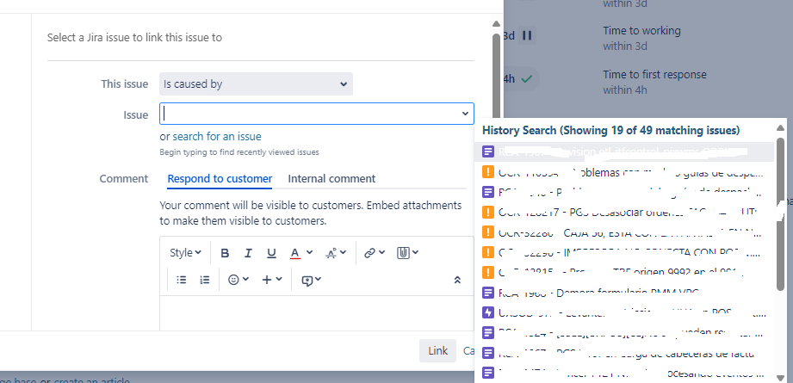
- How do you set up and track dependencies between issues?
- What are JIRA reports, and how do you generate a burndown chart?
- What is a JIRA dashboard, and how do you create and customize widgets?
Advanced JIRA Questions
- How do you integrate JIRA with other tools like Confluence, Bitbucket, or Jenkins?
- How do you automate workflows using JIRA automation rules?
- What is a post-function in JIRA, and how does it work?
- How do you set up permissions and roles in JIRA?
- How do you manage JIRA user access and security?
- How do you handle bulk issue updates in JIRA?
- What are JIRA Service Management and JIRA Align, and how are they different?
- How do you create a custom field in JIRA?
- What is a release note in JIRA, and how do you generate it?
- How do you perform a root cause analysis using JIRA data?

